**COMPUTER PROJECT**

**Python (IDLE)**

**-Mannith and Ram**

**INTRODUCTION**

DocLocker is run on the basis of encrypting and decrypting the data in a specific file. It helps in ensuring some basic security for the data in the file. The data in the file is presented in a vague form so that it is not understood unless the data is decrypted.

**SOFTWARE USED**

* Python(IDLE)

1. Tkinter module
2. os module
3. Sys module
4. Cryptography module

**FLOWCHART**

**The user enters the login credentials**

**The login credentials are validated**

**A window appears with text**

**“Invalid Login”**

**A window appears with 2 tabs with different buttons**

**Valid**

**Invalid**

**Select ‘Upload’ to upload a file**

**A key is shown and the encrypted data is shown in the form of a code**

**A decrypt button is shown in a window and the encrypted data is decrypted and shown to the user if clicked**

**CODE**

import tkinter as tk

from tkinter import ttk

from tkinter import *

from tkinter.filedialog import askopenfilename

from tkinter import messagebox

import sys

from cryptography.fernet import Fernet

import os

creds = 'tempfile.temp' # This just sets the variable creds to 'tempfile.temp'

def Signup(): # This is the signup definition,

global pwordE # These globals just make the variables global to the entire script, meaning any definition can use them

global nameE

global roots

roots = Tk() # This creates the window

roots.title('Signup')

intruction = Label(roots, text='Please Enter new Credentials\n') # This puts a label

intruction.grid(row=0, column=0, sticky=E)

nameL = Label(roots, text='New Username: ')

pwordL = Label(roots, text='New Password: ')

nameL.grid(row=1, column=0, sticky=W)

pwordL.grid(row=2, column=0, sticky=W)

nameE = Entry(roots)

pwordE = Entry(roots, show='*')

nameE.grid(row=1, column=1)

pwordE.grid(row=2, column=1)

signupButton = Button(roots, text='Signup', command=FSSignup)

signupButton.grid(columnspan=2, sticky=W)

roots.mainloop()

def browsefunc():

global my_file

filename = askopenfilename(title='Select A File',filetypes=(('text files','*.txt'),('all files','*')))

path=filename

key=Fernet.generate_key()

print('Key= ',key)

file=open('c:\doclocker\key.key','wb')

file.write(key)#the key will be in type bytes

file.close()

#encrypting the file

input_file=path

with open(input_file,'rb') as f:

data=f.read()

f=Fernet(key)

encrypted=f.encrypt(data)

print('encrypted data=',encrypted)

def decrypt():

global my_file

output_file='c:\doclocker\encryptedfile.txt'

with open(output_file,'wb') as f:

f.write(encrypted)

with open(output_file,'rb') as f:

data=f.read()

print('encrypted content of the file is:', data.decode())

e=Fernet(key)

decrypted_file=e.decrypt(data)

print('the decrypted content of the file is:',decrypted_file.decode())

#asking the user whether he has to decrypt the program or just signout

btn=ttk.Button(text='Decrypt', command=decrypt)

btn.pack()

pathlabel=Label()

pathlabel.pack()

def callback():

messagebox.showinfo("About DocLocker","This Application helps you to encrypt each of your uploaded document with a unique password of your choice 'Created by Mannith and Ram'")

def FSSignup():

with open(creds, 'w') as f: # Creates a document using the variable we made at the top.

f.write(nameE.get()) # nameE is the variable we were storing the input

f.write('\n') # Splits the line so that username and password are in different lines

f.write(pwordE.get())

f.close()

roots.destroy()

Login() #this will open the login window

def Login():

global nameEL

global pwordEL

global rootA

rootA = Tk()

rootA.title('Login')

intruction = Label(rootA, text='Please Login\n')

intruction.grid(sticky=E)

nameL = Label(rootA, text='Username: ')

pwordL = Label(rootA, text='Password: ')

nameL.grid(row=1, sticky=W)

pwordL.grid(row=2, sticky=W)

nameEL = Entry(rootA) #input the name

pwordEL = Entry(rootA, show='*')

nameEL.grid(row=1, column=1)

pwordEL.grid(row=2, column=1)

loginB = Button(rootA, text='Login', command=CheckLogin) # login button is created.

loginB.grid(columnspan=2, sticky=W)

rmuser = Button(rootA, text='Delete User', fg='red', command=DelUser) # delete user button is created

rmuser.grid(columnspan=2, sticky=W)

rootA.mainloop()

def CheckLogin():

with open(creds) as f:

data = f.readlines() #the data in the document is put in the form of variables

uname = data[0].rstrip()

pword = data[1].rstrip()

if nameEL.get() == uname and pwordEL.get() == pword:

r = Tk() # Opens new window

r.title('Document Locker')

r.geometry('500x500') # Makes the window a certain size

rlbl = Label(r, text='\nwelcome to document locker') # "logged in" label

rlbl.pack() # Pack is like .grid(), just different

rlbl2=Label(r,text='Everyone likes PRIVACY',font='Times 30 bold')

rlbl2.pack()

tabControl=ttk.Notebook(r)#created tabcontrol

tab1=ttk.Frame(tabControl)

tabControl.add(tab1, text='File')#creates a tab named file

tabControl.pack()

tab2=ttk.Frame(tabControl)

tabControl.add(tab2, text='Profile')

tabControl.pack(expand=1, fill='both')

btn1t1=ttk.Button(tab1,text='Upload', command=browsefunc)

btn1t1.pack()

pathlabel=Label(r)

pathlabel.pack()

btn3t1=ttk.Button(tab1, text='Want to know about Us?',command=callback)

btn3t1.pack()

btn2t2=ttk.Button(tab2, text='Signout', command=r.destroy)

btn2t2.pack()

r.mainloop()

else:

r = Tk()

r.title('Document Locker')

r.geometry('150x50')

rlbl = Label(r, text='\n[!] Invalid Login')

rlbl.pack()

r.mainloop()

def DelUser():

os.remove(creds) # Removes the file

rootA.destroy()

Signup()

if os.path.isfile(creds):

Login()

else: # The if and else statement check if the user exists..if the user doesnot exist..the signup window is opened

Signup()

***P.S****: a folder named ‘doclocker’ is to be created in the C drive of the computer. Also, a text filed named as encryptedfile has to be created inside the folder named doclocker. The folder stores the key for the encrypted file and the encrypted data is copied into the file ‘encryptedfile’ temporarily. The program, as of now only accepts text documents as an input.*

**OUTPUT**

1. A signup window appears

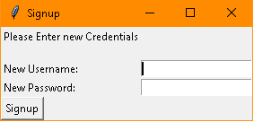

1. Once the signup is complete. A login window appears

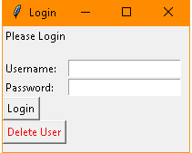

The button ‘Delete User’ deletes the username and password from the tempfile (temporary file) and a signup window is displayed.

1. Once the login credentials are entered, the main window appears with 2 Tabs

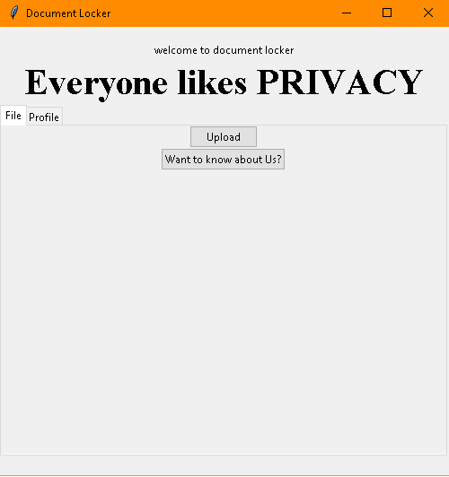

1. If the login is not successful. The following window appears.

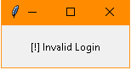

1. In order to encrypt a text file, click on the upload button. A dialog box appears

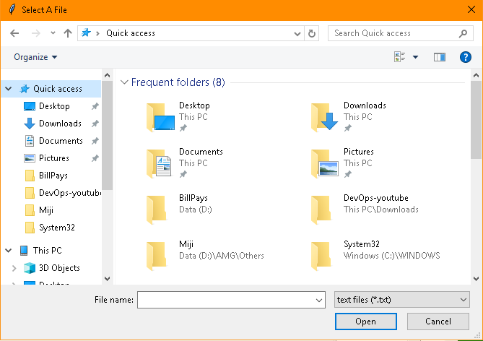

Once a text file is selected, a window with similar information appears(in the python program).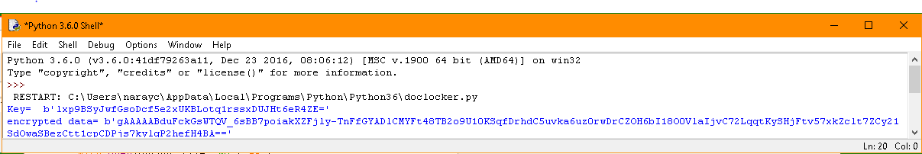

The above image consists of 2 elements ‘key’ and ‘encrypted data’. The data in the selected file is shown to the user in an encrypted form i.e., in the lines of ‘encrypted data’.

The main window now has a button added at the bottom which when clicked decrypts the data

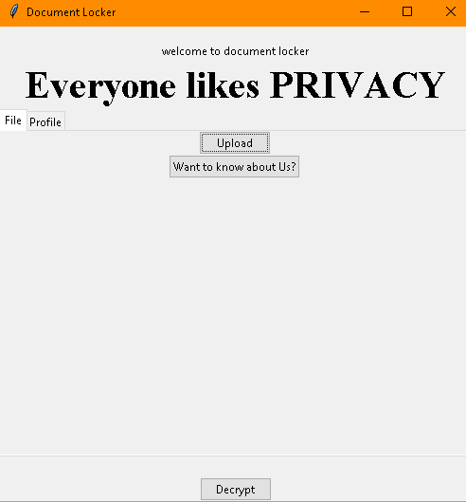

1. Once the Decrypt button is clicked, the python program window shows the decrypted data

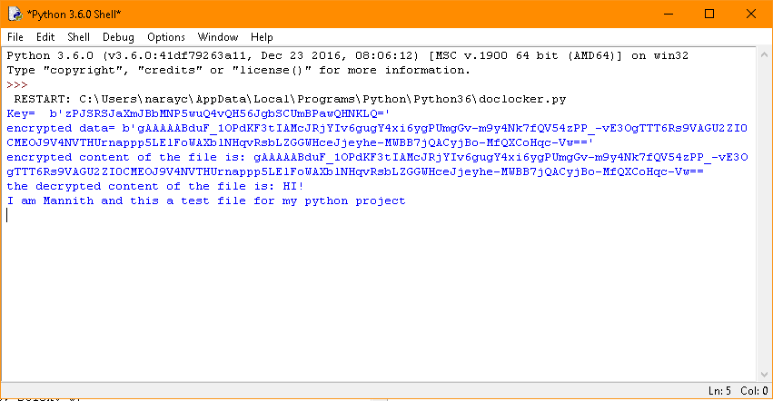

1. The user can sign-out by clicking on the ‘sign out’ button in the profile tab

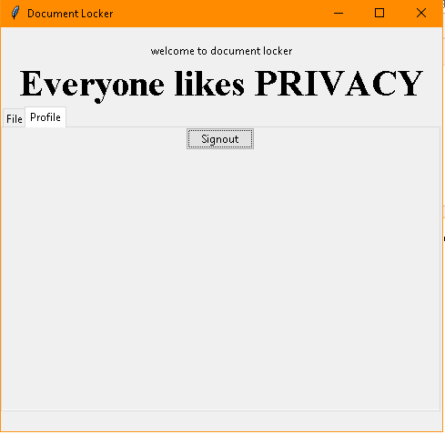

**IMPROVEMENTS FOR VERSION 2**

* A glitch during the start of the program (opening of an empty window) has to be solved.
* The decrypted data can be sent to the user’s desired email address rather than showing it to the user at the same moment.
* A better looking GUI